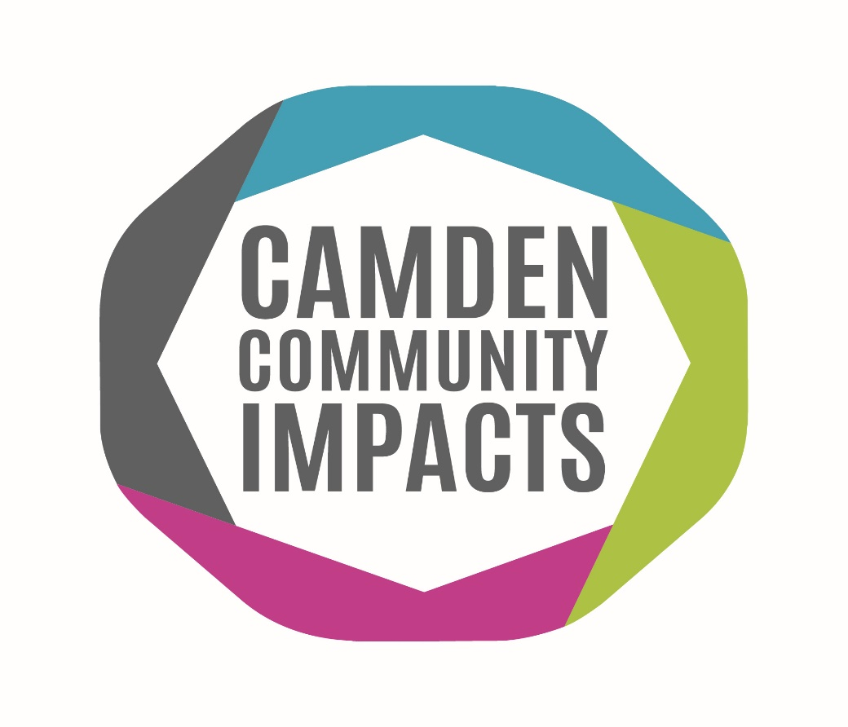

Community Impacts Resilience Fund
Stage 1 Application:
- Recovery Fund
- Partnership and Network Development Fund

These funds are one-off payments in recognition of the support that local organisations have provided to Camden residents during the Pandemic and the financial impact that this has had on them.

Please read the Guidance Notes and Frequently Asked Questions carefully before completing this application form.
When you fill in the application form, please be aware that this funding is for you to increase your ability to contribute to and develop sustainable approaches to delivering against Camden’s Renewal Missions of:
- Food poverty and sustainability: By 2030, everyone eats well every day with nutritious, affordable, sustainable food.
- Diversity in positions of power: By 2030, those holding positions of power in Camden are as diverse as our community – and the next generation is ready to follow.
- Health and sustainability of estates: By 2030, Camden’s estates and streets are creative and sustainable.
- Opportunities for young people: By 2025, every young person has access to economic opportunity that enables them to be safe and secure.

This fund aims to support you to do this by:
- Increasing your organisation’s financial resilience: For example, to provide training to trustees; to develop a new business plan; to develop and deliver a fundraising strategy; maximise the use of a building you manage; or to increase your organisation’s digital capacity.
- Enabling your organisation to respond to new and emerging needs: For example, you may have had to respond to a new community need; to form new partnerships; to reach out to different parts of the community; to deliver services in a different way such as online or through outreach; or establish new provision.

Pre-application eligibility criteria
This will enable you to see if you are eligible to apply to the fund.
- What type of organisation are you? | ☐ Registered, exempted or excepted charity  ☐ Charitable incorporated organisation (CIO)  ☐ Community Interest Company limited by guarantee  ☐ Community benefit society (Industrial and Provident society)  ☐ Faith group, working with the wider community  ☐ Community Amateur Sports Club  ☐ Constituted but unincorporated club or association  ☐ Constituted Tenants and Residents Association or Tenant Management Organisation  ☐ Constituted community group  ☐ Un-incorporated organisation with own bank account and at least two unrelated signatories  ☐ None of the above  If you tick ‘None of the above’, you are not eligible to apply.
- Does your organisation have a focus and a track record of delivering to Camden residents? | ☐ Yes  ☐ No  If you tick ‘No’, you are not eligible to apply.
- Does your organisation have its own bank account with at least two unrelated signatories, or is another organisation willing to hold funds for you? | ☐ Yes  ☐ No  If you tick ‘No’, you are not eligible to apply.
- Does your organisation have a minimum of three trustees and/or is it an unincorporated organisation with an agreement/ articles of association in place? | ☐ Yes  ☐ No  If you tick ‘No’, you are not eligible to apply.
- Are you able to provide copies of your most recent annual accounts? | ☐ Yes  ☐ No  If you tick ‘No’, you are not eligible to apply.
- Does your organisation pay all employees and contracted staff the London Living Wage as a minimum? | ☐ Yes  ☐ No  If you tick ‘No’, you are not eligible to apply.
- If you are a faith organisation, are you undertaking work that benefits the wider community? | ☐ Yes  ☐ No  ☐ Not Applicable  If you tick ‘No’, you are not eligible to apply.
- Is your annual income less than £2m? | ☐ Yes  ☐ No  If you tick ‘No’, you are unlikely to be awarded a grant.

1. About your Organisation
Organisation Details
Name of organisation
Charity Number (if applicable)
Company Number (if applicable)
Address
Website address/Social Media handles
Main Contact Details
Name
Job Title
Telephone
Email address
Secondary Contact Details
Name
Job Title
Telephone
Email address
Chair of Trustee or equivalent
Name
Job Title
Telephone
Email address
Charitable Objectives
What are the charitable objectives of your organisation? Please describe what your organisation does? (100 words)
Is your organisation’s mission focused on tackling inequalities and advancing the rights of a particular group? |  | ☐ Black, Asian and Minority Ethnic (BAME)  ☐ Deaf and Disabled  ☐ Lesbian, Gay, Bisexual and Transgender (LGBT+)  ☐ Women  ☐ Other - please describe:
Please select which of these themes most describes the focus of your organisation’s usual work |  | ☐ Advice  ☐ Arts and culture  ☐ Children and young people  ☐ Domestic abuse / violence against women and girls  ☐ Equity and inclusion  ☐ Food  ☐ Homelessness  ☐ Infrastructure (civil society support organisations or community anchor organisations)  ☐ Mental health  ☐ People at risk (including older people, disabled people, and people with long-term physical health conditions)  ☐ Refugees and migrants  ☐ Other- please describe:
Which geographical area does your organisation cover? E.g., a particular ward or the whole of Camden.
How many trustees does your organisation have? If none then please describe how your organisation is managed.
Does your organisation operate out of a fixed space or venue?  If your organisation delivers most or all of it’s public-facing work (i.e. not your office based activities) from one building, you should answer ‘yes’. If your organisation simply hires a room regularly or occasionally to deliver a club, workshops or events, you should answer ‘no’ to this question. |  | ☐ Yes  ☐ No
Building address if different from organisation address
Please provide us with an overview of your organisation
Maximum 300 words
Total Word Count:

2. Funding Request
Which fund/s are you applying to?  Organisations can apply for both grants but please be aware that there will likely be more applications than funds and it is unlikely that organisations will be awarded grants from both funds. | ☐ Recovery Fund – please only complete section 2.1.  ☐ Partnership and Network Development Fund – please only complete section 2.2.  ☐ Both Funds – please complete sections 2.1. and section 2.2.

2.1. Funding Request – Recovery Fund
Please complete this if you are applying for the Recovery Fund
The Recovery Fund is a one-off grant that can be used to cover core costs, this could include retrospective costs incurred during the financial year 21/22.
2.1.0 How much are you applying for (up to £15,000)?

2.1.1 Summarise your funding request in no more than 50 words "This funding is for… and we need it because..."
Maximum 50 words.
Total Word Count:

2.1.2. Please expand on your funding request here. What difference will the grant make to your organisation and the people you work with?
Maximum 250 words.
Total Word Count:

2.2. Funding Request – Partnership and Network Development Fund
Please complete this if you are applying for the Partnership and Network Development Fund

The Partnership and Network Development Fund is core funding that will be available to organisations to develop partnerships or networks over a year, without the need to deliver a project.

2.2.1 How much are you applying for (up to £10,000)?

2.2.2. Tell us about the main partners your organisation will work/works with on this partnership. Partners are other organisations, such as other charities, local government, or businesses. Tell us about your relationships with these orgs for example, you might have a formal contract to deliver work with them, an informal relationship to support each other’s work, or you might refer people to them or accept referrals from them.
Maximum 100 words.
Total Word Count:

2.2.3. Summarise your funding request in no more than 50 words "This funding is for… and we need it because..."
Maximum 50 words.
Total Word Count:

2.2.4. Please expand on your funding request here. What difference will the grant make to your organisation and the people you work with?
Maximum 250 words.
Total Word Count:

2.2.5. Explain the purpose of your existing or proposed partnership / network including how and why it is formed.
Maximum 100 words.
Total Word Count:

3. Camden’s Renewal Missions and Your Response to COVID-19
3.1. Which aspects of Camden’s Renewal Missions do you believe your service meets? And how?
Maximum 100 words.
Total Word Count:

3.2. Please tell us how your organisation supported residents during the Covid pandemic? How did you know what the need was?
Maximum 100 words.
Total Word Count:

3.3. Is there any other information you wish to share with us that you feel would add value to your application?
Maximum 100 words.
Total Word Count:

4. Financial Information
We know that the last two years have been unusual for groups in relation to fundraising and income generation. As well as assessing your financial track record this will help us to assess the financial impact of the pandemic.

Your organisation’s financial information
4.1. What was your organisation’s income in 2020/21 |  |  |  | £
4.2. What was your organisation’s expenditure in 2020/21 |  |  |  | £
4.3. What non-committed cash reserves did your organisation have on 31/3/2021 |  |  |  | £
4.4. Please tell us how your organisation has been financially impacted by Covid.
Maximum 100 words.
Total Word Count:
4.5. Please use this space to provide any additional information about your finances

5. Declaration
In submitting this Application Form, the named contact is agreeing to the following statement on behalf of your organisation.
“The information I have provided is accurate as far as I know. If I discover that the information is inaccurate, I will notify the Council immediately and will provide the accurate information as soon as possible. I confirm that my organisation meets all the basic Eligibility Criteria listed in Guidance Notes. I am aware that I may be asked to provide further evidence to support the information provided and agree to do so if requested.”
Please email your application form to Camden Council’s Voluntary and Community Sector Team at: VCS@Camden.gov.uk

The closing date for applications to be submitted is 11pm on 29th November 2021.

Applications submitted after this deadline will not be accepted.

