Camden Libraries
Winter Reading Challenge
Suitable for children aged 0-12

Starts on 1 December 2022 and ends
on 20 February 2023
Sign up at your local Camden library
To find your local library visit us www.camden.gov.uk/libraries
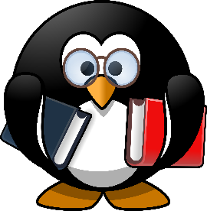
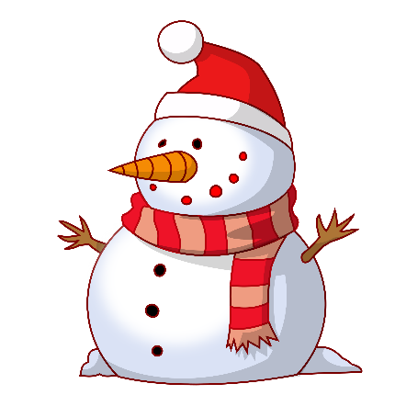
Write a book review, win prizes and the best of your reviews will be shared on our website.
Read four or more books to complete
the challenge and receive a certificate.

