Halloween crafts

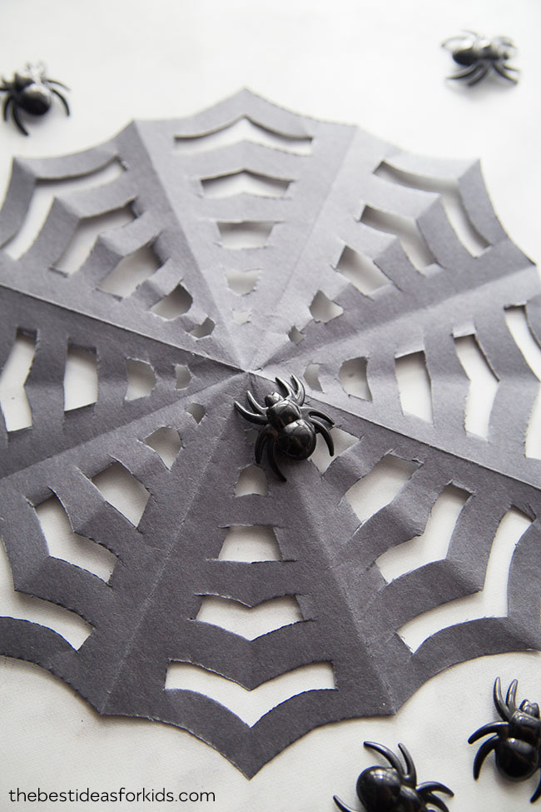
We used construction paper to make our paper spider web. You can also use large garbage bags to make extra-large spider webs for decorations. The thinner the material you can work with the better. This is because the folding can make the cutting part difficult. Colored printer paper would also work well. We wouldn’t recommend cardstock since it is too thick.
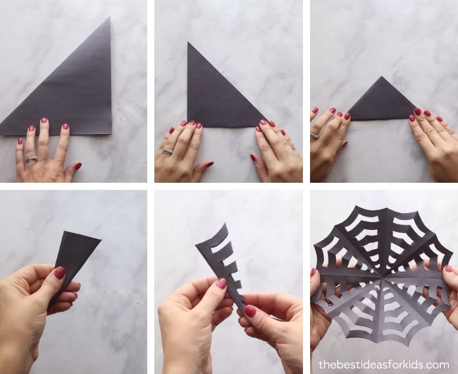
1. First, fold your paper over to make it a square size. Cut off the remaining paper. Keep the paper in the triangle shape from the first fold.
2. Fold over again.
3. Fold over again.
4. Fold over a 4th time. Cut off the excess paper from the bottom and angle the cut in slightly so that when unfolded the spider web has a concave on the outside. Note: in the video, cutting the concave shape is not shown.
5. On the folded part of your final triangle, cut in slits all the way down. Space these out however you like. The thinner you make them the more webbing there will be. We made 5 cuts and we were happy with the end result. You can also angle the cut marks to make the spider web have a concave shape.

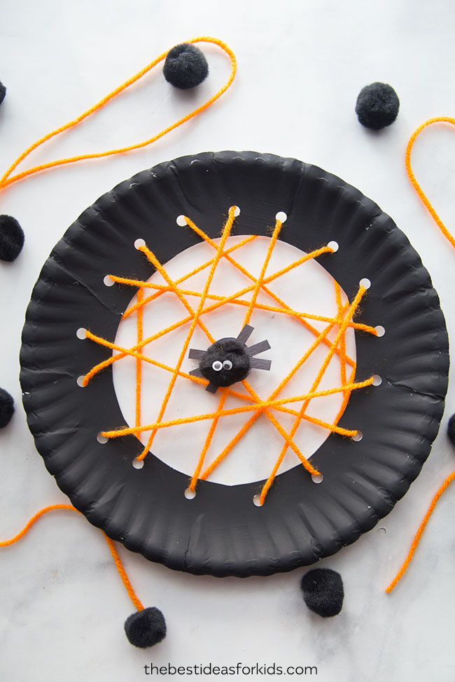

The supplies you’ll need are: Orange yarn, black paint, paper plate, black paper, small googly eyes and a large black pom pom.
1. First, cut out the center of your paper plate and paint it black. Using a hole puncher, punch holes all around the center.
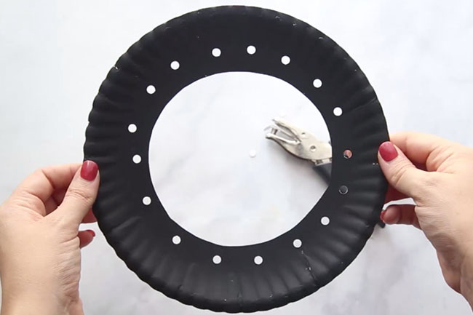
2. Use your yarn and thread through all of the holes in your paper plate. You can tape the ends to the back when you start and when you’re finished.
3. Make a small spider! You can add a paper spider or we made a pom pom spider. We made the legs with just paper strips and glued these to a circle paper the same size as the pom pom. Then we glued the pom pom on top and added two small googly eyes.
Note: Spiders have 8 legs and while we only added 6 due to sizing you can definitely make 8 legs!

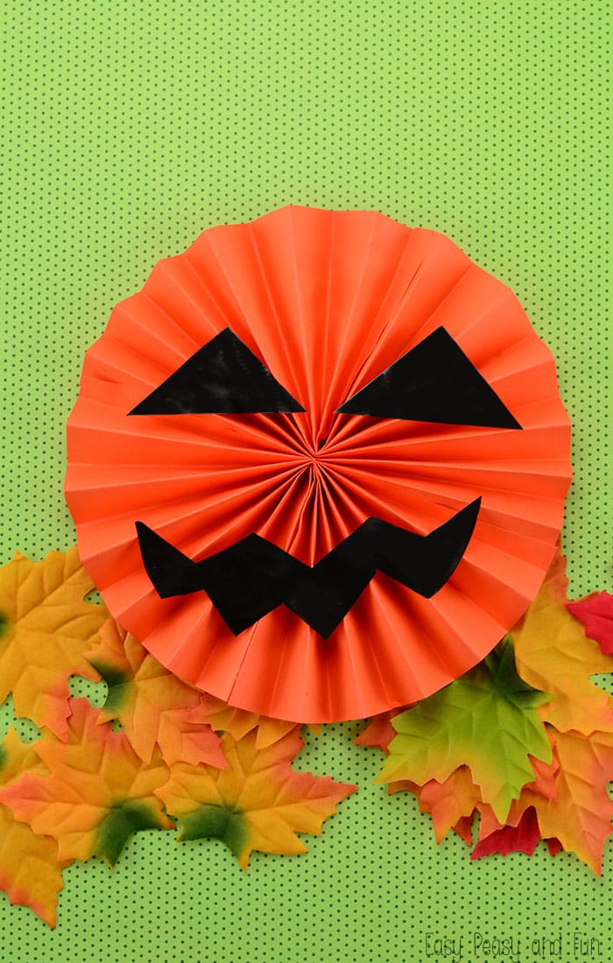

Paper Jack O’Lantern Craft
What you’ll need
- 2 sheets of orange letter or A4 sized papers
- black paper
- scissors
- glue
- string
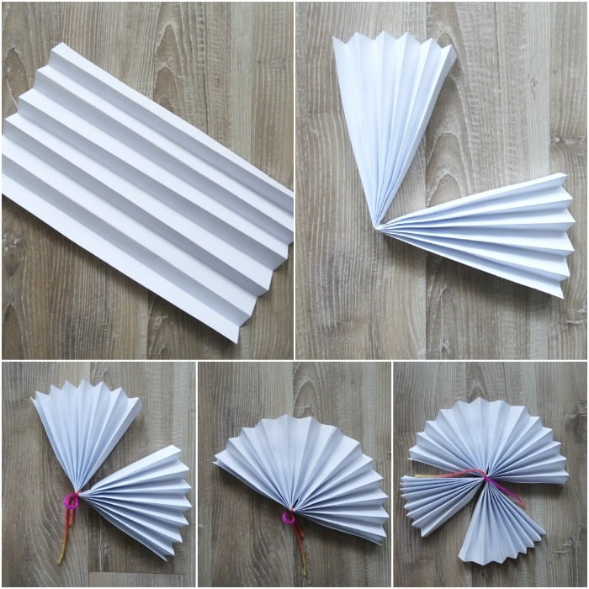
Fold the paper link an accordion. Fold in half and tie with string. Glue together.
Do the same with the second piece of paper. Now tie them both together and glue them together. You’ve got a paper pinwheel!
Cut the scary (or cute) facial expressions for your Jack O’lantern. Glue them on the pinwheel (white school glue worked out great for us, although I think a low temp glue gun would be even better).
These little pumpkins will look great on windows, doors, walls or hanging from the ceiling twisting and turning in the air.

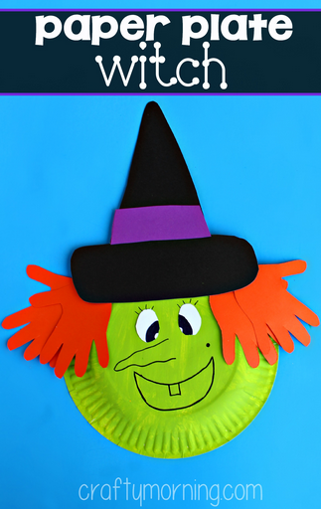
Materials Needed:
- Paper plate
- Green paint
- Purple, black, orange, white paper
- Black sharpie
- Scissors
- Glue
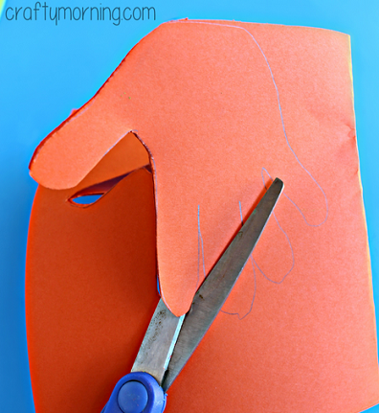
Trace your child’s handprint on top of 2 pieces of orange paper folded so you only have to cut once!
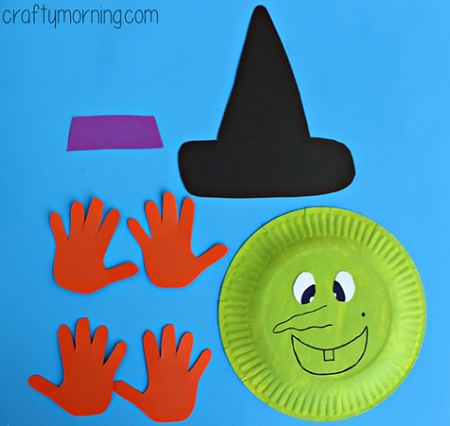
Paint the paper plate with green paint and set aside to dry. Cut out a witch’s hat and the eyeballs (we used sharpie to make the pupils). Once the green paint is dry, glue on the hat, handprint “hair,” and the eyes. Draw on a witches face and you’re done!

