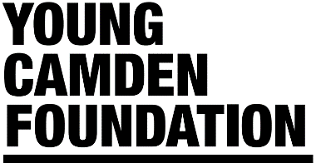
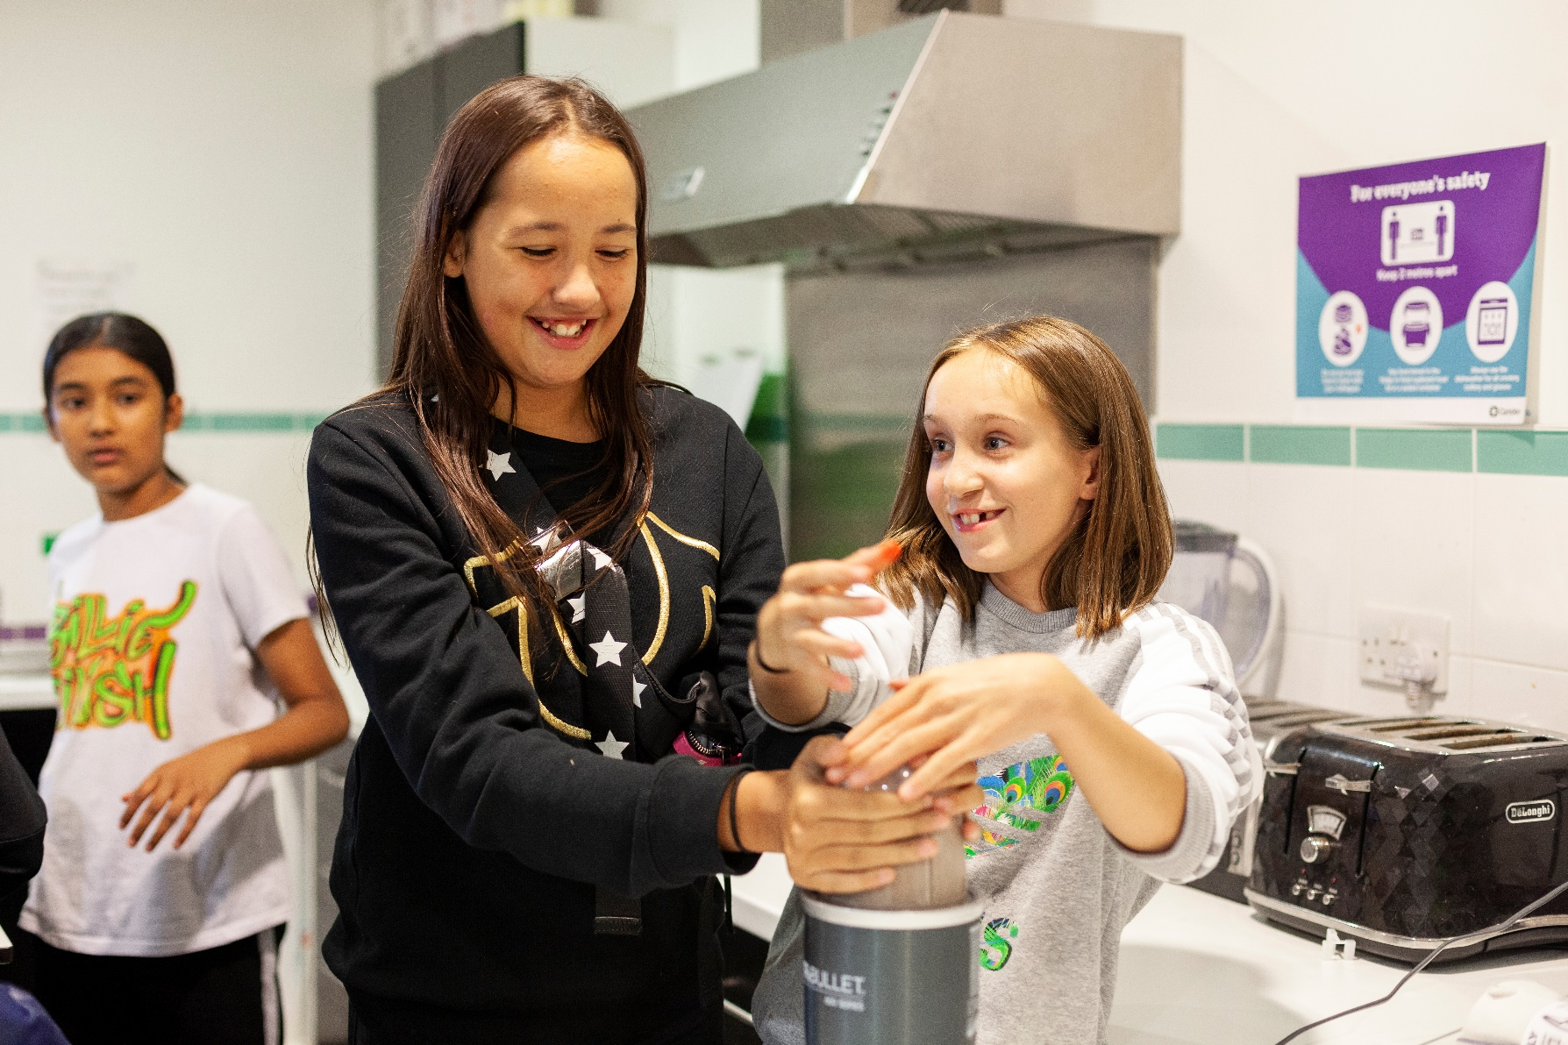
CAMDEN HOLIDAY ACTIVITIES FUND
Expression of interest form

About this form

This form should be used to submit an expression of interest for funding from the Camden Holiday Activities Fund to set up a Holiday Hub. You must submit your expression of interest by 5th March 2021, using this form.

Please use this form and e-mail the completed version to info@youngcamdenfoundation.org.uk, with the subject line ‘Camden Holiday Activities Fund EOI’.

The form is made up of three sections and allows you to provide information about your organisation(s) and the project for which you are seeking funding.

Section 1 - requires some basic contact information so that we can get in touch with you about your expression of interest.

Section 2 – this is where you should provide information on your organisation, and any other partner organisations involved in the project.

Please note that if you’re applying for funding as a consortium of multiple organisations, one organisation should submit an expression of interest as the lead applicant; including details of partner organisations where requested.

Section 3 - in this section we ask you to give a brief description of the project for which you are seeking funding and how it meets the minimum eligibility criteria below:

- Able to provide at least one meal per day (which meets School Food Standards: https://www.gov.uk/government/publications/school-food-standards-resources-for-schools), access to physical activity/enriching activity, and age-appropriate nutritional education
- Able to deliver the programme in line with the 4x4x4 model – at least 4 hours for 4 days a week. For 4 weeks in the summer, and/or for a week in Easter and Christmas
- Target children and young people (5-16yrs old) eligible for free school meals
- Provide inclusive and accessible provision (e.g. LDD and SEND)
- Have the necessary policies and procedures in place to set up a Holiday Hub (safeguarding, data protection etc.)

Please do not exceed the word limits for each question

Please note you may be contacted by Young Camden Foundation to discuss your expression of interest in more detail.

Section 1 – Contact information

Applicant contact name
Click here to enter text.
Applicant contact e-mail
Click here to enter text.
Applicant contact phone number
Click here to enter text.
Lead organisation address
Click here to enter text.

Section 2 – Your organisation(s)

Please provide the name of your lead organisations and any partner organisations? Please provide registered company and/or charity numbers where applicable.
Click here to enter text.
Please state the aims and objectives of your lead organisation? Please provide a mission statement where available. (max. 150 words per organisation)
Click here to enter text.
Please specify the lead organisation’s annual income and expenditure.
Click here to enter text.
Please use this space to highlight any examples of recent activity by your organisation(s) that may be relevant to the Holiday Activities Fund. (max. 150 words)
Click here to enter text.

Section 3 – Your proposal

Please provide a summary of your proposal. Please include the planned approach to be taken, the logic behind this and anticipated results and outcomes.
The HAF Programme has 5 KEY outcomes for children and young people attending the holiday provision.
Please give a short description against each outcome to show how you plan to achieve this.
Programme OUTCOMES | How will your project achieve this outcome?
1. Eat more healthily | Click here to enter text.
2. Be more active | Click here to enter text.
3. Take part in engaging and enriching activities | Click here to enter text.
4. Be safe and not isolated | Click here to enter text.
5. Have greater knowledge of health and nutrition.  *We can provide support with developing and/or delivering sessions, but you will need show how this will be incorporated into your overall programme of delivery. | Click here to enter text.

Please explain why you think a Holiday Hub is needed in the part of the borough you serve. Please provide details of how a Holiday Hub will impact the area your serve. (max. 200 words)
Click here to enter text.
Please explain how you could deliver your proposal in line with COVID-19 government guidelines if required. (max. 200 words)
Click here to enter text.
How many participants do you expect to reach during each of Easter, Summer and Christmas holidays?
Click here to enter text.
Please tell us how these numbers will be impacted by COVID-19:
- How many could you reach with a virtual offer plus food delivery
Click here to enter text.
- With face-to-face COVID-19 restricted places and offsite allowance
Click here to enter text.
- No COVID-19 restrictions in place
Click here to enter text.
We are considering grants of up to £1,250 each week per Holiday Hub (based on 40 children). Please state the amount of funding you wish to apply for – providing a breakdown of amounts for each period of delivery (Easter, Summer, Winter).
Click here to enter text.
If you think you will need additional funding, please tell us how much, your reason, and how you will use the additional funding
Click here to enter text.
Please let us know if you would like any other support from Young Camden Foundation or the Council – e.g. linking with food or activity specialists, training on any aspects of delivery etc?
Click here to enter text.

