Basement Impact Assessment
pro forma 1v0

Use of this Pro Forma
A Basement Impact Assessment (BIA) is required for all planning applications for new or extended basements in Camden.
Basement Impact Assessments are technical documents and they must be prepared in general accordance with planning policies, guidance and technical procedures set out in the documents referenced in this pro forma.
This pro forma has been prepared as a guide to drafting policy compliant Basement Impact Assessments, based on detailed knowledge of Camden Planning Guidance and the Local Plan Policy A5.

Applicants and engineers are not required to use the document as an actual template, but, in order to ensure that all aspects of the BIA requirements have been addressed, Applicants are encouraged to adopt the headings provided and include information on all relevant topics under those headings to ensure that they meet all of the Council’s expectations. Use of non-standard formats may result in delay or additional costs associated with the independent audit.
It should be noted that BIAs are required to meet Camden Planning Guidance and Policies, but this does not override the need to meet Building Regulations at the appropriate time.
Throughout this document we provide these reference notes to highlight topics or issues that need to be considered in preparing the BIA.

The content of this document has been prepared in accordance with the scope of Campbell Reith Hill LLP’s (CampbellReith) appointment with its client and is subject to the terms of the appointment. It is addressed to and for the sole use and reliance of CampbellReith’s client. CampbellReith accepts no liability for any use of this document other than by its client and only for the purposes, stated in the document, for which it was prepared and provided. No person other than the client may copy (in whole or in part) use or rely on the contents of this document, without the prior written permission of Campbell Reith Hill LLP. Any advice, opinions, or recommendations within this document should be read and relied upon only in the context of the document as a whole. The contents of this document are not to be construed as providing legal, business or tax advice or opinion.

Introduction
A Basement Impact Assessment (BIA) is required for all planning applications with basements in Camden.
Basement Impact Assessments must be prepared in general accordance with policies and technical procedures contained within the documents listed below.

Supporting documents and other information about basement development in Camden is available to download from Camden’s website:
https://www.camden.gov.uk/basements
.

- Guidance for Subterranean Development (GSD). Issue 01. November 2010. Ove Arup & Partners.
- Camden Planning Guidance (CPG): Basements (March 2018).
- Camden Local Plan 2017 (: Policy A5 Basements and Policy CC3 Water and flooding.
Policy A5 Basement Requirements
Camden’s Local Plan 2017 Policy A5 ‘Basements’ is the essential planning policy which must be satisfied in order for basement development to be acceptable.
The Council will only permit basement development where it is demonstrated to its satisfaction that the proposal will not cause harm to neighbouring properties or the structural, ground, or water conditions of the area.
The policy sets out that the siting, location, scale and design of basements must have minimal impact on, and be subordinate to, the host building and property. Basement development should:
- not comprise of more than one storey;
- not be built under an existing basement;
- not exceed 50% of each garden within the property;
- be less than 1.5 times the footprint of the host building in area;
- extend into the garden no further than 50% of the depth of the host building measured from the principal rear elevation;
- not extend into or underneath the garden further than 50% of the depth of the garden;
- be set back from neighbouring property boundaries where it extends beyond the footprint of the host building; and
- avoid the loss of garden space or trees of townscape or amenity value.
Exceptions to the above may be made on large comprehensively planned sites. It is recommended that development proposals are discussed with LBC at the outset of any development planning.

The BIA should demonstrate that schemes:
- maintain the structural stability of the building and neighbouring properties;
- avoid adversely affecting drainage and run off or causing other damage to the water environment;
- avoid cumulative impacts upon structural stability or the water environment in the local area.
The BIA should evaluate the impacts of the proposed basement considering hydrology, hydrogeology and land stability via the process described by the GSD and make recommendations for the detailed design.
Note that the full requirements of the policy include preventing impacts to a wider range of criteria which are not specifically addressed by this guidance note, but which should be considered by the applicant, in consultation with the London Borough of Camden (LBC).
In determining proposals for basements and other underground development, the Council will require an assessment of the scheme’s impact on drainage, flooding, groundwater conditions and structural stability in the form of a Basement Impact Assessment and where appropriate, a Basement Construction Plan.

For

[Client Name]
Project Number: [Project No]
[Date]
[Project Name]

Basement Impact Assessment
Planning reference no [if known]

Revisions & additional material

All documents within a BIA submission should clearly indicate the site address and planning reference number (where known).
Document numbers, revision numbers and dates of submission should be provided to ensure that only current documents are considered during the planning and BIA audit processes.

Document History and Status
Revision | Date | Purpose/Status | File Ref | Author | Check | Review

Document Details
Last saved | 01/01/1601 00:00
Path | Document1
Author
Project Director
Project Number
Project Name
Planning Reference No.

Additional supporting documents
Please note – the review process will be quicker if these are submitted as Word documents or searchable PDFs.
Date | Version | Produced by

Please list all revisions here: 1
Date | Version | Produced by

All assessment and supporting documents should be referenced to ensure their inclusion in the planning and BIA audit processes.

Contents
1.0 Non-Technical Summary 6
2.0 Introduction 8
2.1. Authors 9
2.2. Sources of Information 9
2.3. Existing and Proposed Development 10
3.0 Desk Study 12
3.1. Site History 12
3.2. Geology 12
3.3. Hydrogeology 12
3.4. Hydrology, Drainage and Flood Risk 14
3.5. Other Information 14
4.0 Screening 15
4.2. Slope Stability 15
4.3. Surface Water and Flooding 16
4.4. Non-Technical Summary of Screening Process 17
5.0 Scoping 18
5.1. Example 1 18
5.2. Example 2 18
5.3. Example 3 19
5.4. Example 4 19
6.0 Site Investigation/Additional Assessments 20
6.1. Site Investigation 20
6.2. Additional Assessments 20
7.0 Construction Methodology/Engineering Statements 21
7.1. Outline Geotechnical Design Parameters 21
7.2. Outline Temporary and Permanent Works Proposals 21
7.3. Ground Movement and Damage Impact Assessment (if required) 22
7.4. Control of Construction Works 23
8.0 Basement Impact Assessment 24
8.2. Land Stability/Slope Stability 25
8.3. Hydrogeology and Groundwater Flooding 25
8.4. Hydrology, Surface Water Flooding and Sewer Flooding 26

Appendices

Appendix 1: Desk Study References
Site Location Plan
Other mapping/data as required to evidence Screening assessments, for instance:
- Pertinent Historical Map Extracts
- WW2 Bomb Damage Map Extract
- Slope Angle and Worked Ground Map (LB Camden GHHS figure 16)
- Geological Map Extract, BGS (Geology of Britain Viewer)
- Flooded Streets Map (LB Camden GHHS Figure 15)
- Flood Risk Map, Environment Agency (Surface Water Flood Risk)
- Groundwater Source Protection Zone (LB Camden GHHS Figure 11)
- Transport for London Property Asset Register
Appendix 2: Site Investigation Data
Appendix 3: Existing and Proposed Development Drawings
Appendix 4: Ground Movement and Damage Impact Assessment
Appendix 5: Structural Engineer's Statement and Calculations
Appendix 6: Arboricultural Report/Other Reports (as required)
Appendix 7: Utility and Infrastructure Consultations

Non-Technical Summary

A ‘non technical summary’ of the evidence gathered for each stage of the BIA should be presented in a format which can be fully understood by those with no technical knowledge, as required by CPG Basements (para 4.6) and Policy A5 of the Camden Local Plan (para 6.118).

    - The site location is…..address….reference location plan
    - The current site arrangement is…..description…drawings, photos as required
    - The proposed development comprises…..description….drawings
    - The following assessments are presented:
- Desk Study
- Screening
- Scoping
- Additional evidence/assessments (as required)
  - Site investigation
  - Arboricultural report
  - Ground movement assessment
  - Consultation with adjacent infrastructure/asset owners
  - Flood risk assessments
  - Surface water drainage strategy/SUDS assessment
  - Others
- Impact Assessment

    - The authors of the assessments are……name of authors, qualifications and experience

Qualifications to be demonstrated in accordance with CPG Basements paragraph 4.7.

    - The ground and groundwater conditions beneath the site are….. summary description
    - The construction methods proposed are……. summary description
    - A structural monitoring strategy to control the works and impacts to neighbouring structures will comprise ……… summary description
    - The BIA has assessed land stability and the impacts of the proposed development on neighbouring structures will be……. Burland Scale impacts

Burland Scale damage no greater than Category 1 is permitted by Policy A5 Basements.

    - The BIA has identified the following….potential slope stability impacts……..the following mitigation measures are proposed…….the residual impacts to slope stability are……….
    - The BIA has identified the following….potential hydrological impacts……..the following mitigation measures are proposed…….the residual impacts on the wider hydrological environment are……….

Note especially drainage requirements of CPG Basements, in section “Principal impacts of basements in Camden” beginning in paragraph 4.43.

    - The BIA has identified the following….potential hydrogeological impacts……..the following mitigation measures are proposed…….the residual impacts on the wider hydrogeological environment are……….(consider also cumulative impacts)
    - The BIA has identified… a very low/low/medium/high flood risk for the proposed development……the proposed mitigation measures are……….The residual flood risk is…….

Introduction

The information and assessments provided within the BIA must be produced specifically to meet the requirements of LBC, including Planning Guidance - Basements (Camden Planning Guidance, March 2018) - and the Local Plan (A5 Basements, July 2017).
The BIA shall be audited in accordance with LBC’s Audit Process Terms of Reference.
Provision of incomplete information or assessment will result in the BIA not being accepted as compliant with the relevant policies. This will result in either rejection of the planning application or the requirement to re-submit a policy compliant BIA. In addition to delaying the planning process, this is likely to incur additional costs for the Applicant.

The purpose of this assessment is to consider the effects of a proposed basement development at ….. Street Address, London, Post Code…. on the local hydrology, geology and hydrogeology and potential impacts to neighbours and the wider environment. The site location is presented in…….. (map xx).
The BIA approach follows current planning procedure for basements and lightwells adopted by LB Camden and comprises the following elements (CPG Basements):
- Desk Study;
- Screening;
- Scoping;
- Site Investigation, monitoring, interpretation and ground movement assessment;
- Impact Assessment

Authors

Authors’ qualifications to be demonstrated in accordance with CPG Basements, paragraph 4.7.

    - The BIA has been authored/reviewed/approved by………..authors’ qualifications and experience

Sources of Information

The Camden Geological, Hydrogeological and Hydrological Study - Guidance for Subterranean Development (produced by Arup, 2010) – is available for download (refer to introductory notes). The BIA authors should be familiar with this document and its requirements, notably Appendices G1, G2 and G3, and make use of the provide reference mapping data during the Screening process.
All sources information referenced within the BIA should be listed.

The following baseline data have been referenced to complete the BIA in relation to the proposed development:
- Site walkover and discussion with residents…..(date);
- Current/historical mapping….(references);
- Geological mapping….(references);
- Hydrogeological data…..(references);
- Current/historical hydrological data…..(references);
- Flood risk mapping….(references);
- LB Camden, Strategic Flood Risk Assessment (produced by URS, 2014);
- LB Camden, Floods in Camden, Report of the Floods Scrutiny Panel (2013);
- LB Camden, Planning Guidance (CPG) – Basements (March 2018);
- LB Camden, Camden Geological, Hydrogeological and Hydrological Study – Guidance for Subterranean Development (produced by Arup, 2010);
- LB Camden, Local Plan Policy A5 Basements (2017);
- LB Camden’s Audit Process Terms of Reference;
- Other relevant technical references pertinent to the proposed development, construction methods, etc.

The Camden Geological, Hydrogeological and Hydrological Study - Guidance for Subterranean Development (produced by Arup, 2010) – is referred to throughout this document as GHHS.

Existing and Proposed Development

It is essential that the nature of the existing site and the proposed development are accurately described, including the immediate area in the vicinity of the site which could be deemed within the zone of influence of the proposed development works.
.

    - The Application site is located……..the site is within/not within a wider hillside setting………slope angles are…..

The Slope Angle and Worked Ground Map of Camden is presented in the GHHS, figure 16.

    - Description of site……..the site elevations are……..the site slope angle is…………
    - Description of current property/structures on site…….the condition of the structures is…….
    - Description of adjacent properties/structures…………foundation depths/basement depths of neighbouring properties are……..the condition of neighbouring structures is……..
    - Neighbouring buildings include the following Listed properties…..
    - Neighbouring gardens and trees are present at….(locations) and will be protected in accordance with…..(A5 Basements (Local Plan 2017)
    - Adjacent infrastructure includes………(highways, railway assets etc)……. asset owners have been consulted and the correspondence is presented……(Appendix xx).
    - Underground infrastructure present beneath/close to the site includes……..(railway tunnels, (utilities etc)……..asset owners have been consulted and the correspondence is presented……(Appendix xx).
    - Existing and Proposed development drawings are presented in………(Appendix xx).

Dimensioned drawings must be provided, in both plan and section view. Dimensions and elevations should be consistent across the full suite of submitted BIA supporting documents, and should include distances to adjacent structures.

    - The proposed development will utilise the following construction techniques…….clear description of all proposed methodologies…..
    - The outline construction programme for the proposed development is……….(Appendix xx).
Note : Policy A5 Basement Requirements
The siting, location, scale and design of basements must have minimal impact on, and be subordinate to, the host building and property. Basement development should:
- not comprise of more than one storey;
- not be built under an existing basement;
- not exceed 50% of each garden within the property;
- be less than 1.5 times the footprint of the host building in area;
- extend into the garden no further than 50% of the depth of the host building measured from the principal rear elevation;
- not extend into or underneath the garden further than 50% of the depth of the garden;
- be set back from neighbouring property boundaries where it extends beyond the footprint of the host building; and
- avoid the loss of garden space or trees of townscape or amenity value.

Desk Study

The Desk Study should be undertaken in accordance with GHHS Appendix G1, to include the following sections as a minimum.

Site History
    - With reference to…..description of site history, noting previous land uses and any pertinent information (e.g. potential for worked ground/deep Made Ground, WW2 bomb strikes, previous basement / underground structures on site or adjacent etc)….

Geology
    - The British Geology Survey (BGS) map of the area (reference) indicates that the site is underlain by….description of geology….If relevant, reference site investigation data presented in section (x) and Appendix (xx)….

The geological map of Camden is provided in the GHHS, Figures 3, 4, 5, 6, 7.

Hydrogeology

The Environment Agency (EA) Groundwater Protection Policy uses aquifer designations. These designations reflect the importance of aquifers in terms of groundwater as a resource (drinking water supply) and also their role in supporting surface water flows and wetland ecosystems.

    - The geology underlying the site is classified as….,.e.g. a principal/secondary aquifer, unproductive strata etc….….If relevant, reference also site investigation data is presented in section (x) and Appendix (xx)….
    - LB Camden data indicates the site….is / is not within a groundwater source protection zone……

Groundwater Source Protection Zone information for Camden is provided in the GHHS, Figure 8.

Hydrology, Drainage and Flood Risk

Relevant reference information is provided in:
- Watercourses, GHHS Figure 11
- Surface Water Features, GHHS Figure 12
- Hampstead Heath Surface Water Catchments and Drainage, GHHS Figure 14
- LB Camden, Strategic Flood Risk Assessment (Figure 6)
- Flood Map, GHHS Figure 12
Additional reference material is available from other sources e.g. Environment Agency.

    - The site is located within…… xxxm of surface water features (current water courses)… potential impacts relating to the proximity of these watercourses are…..
    - The site is located within…… xxxm of…..(historical water courses)… potential impacts relating to the proximity of these watercourses are…..
    - The site….is/is not within the catchment of the Hampstead Heath Pond Chain, which is xxxm to the (direction)… potential impacts are…..
    - The site surface area is currently …… percentage impermeable/percentage permeable….. describe current surfacing, run-off and drainage arrangements…reference drawings/surveys…
    - The proposed surface area will be….…… percentage impermeable/percentage permeable….. describe surfacing, run-off and drainage arrangements…reference drawings / surveys…
    - The site is classified as….very low/low/medium/high risk of surface water flooding/reservoir flooding / sewer flooding and / or is within a Local Flood Risk Zone…… potential impacts are…..
    - The site….is/is not within a Critical Drainage Area.

Other Information

In accordance with the GHHS Appendix G1, all potential risks / impacts to stability and the water environment should be considered. Additional information should be provided, as required, to demonstrate adequate assessment. A full utilities search should be undertaken.

Screening

Note requirements of CPG Basement paragraphs 4.8 - 4.13 and GHHS Appendix F. All questions should be addressed with answers (Yes, No, Unknown) evidenced by a reference to sources of information / assessment provided within the BIA and supporting documents.

    - A screening process has been undertaken and the findings are described below.
Question | Response | Details
1a. Is the site located directly above an aquifer? | - | Evidence
1b. Will the proposed basement extend beneath the water table surface? | - | Evidence
2. Is the site within 100mof a watercourse, well (used / disused) or potential spring line? | - | Evidence
3. Is the site within the catchment of the pond chains on Hampstead Heath? | - | Evidence
4. Will the proposed basement development result in a change in the proportion of hard surfaced / paved areas? | - | Evidence
5. As part of site drainage, will more surface water (e.g. rainfall and run-off) than at present be discharged to the ground (e.g. via soakaways and/or SUDS)? | - | Evidence
6. Is the lowest point of the proposed excavation (allowing for any drainage and foundation space under the basement floor) close to, or lower than, the mean water level in any local pond (not just the pond chains on Hampstead Heath) or spring line? | - | Evidence

Slope Stability
Question | Response | Details
1. Does the existing site include slopes, natural or man-made greater than 7 degrees (approximately 1 in 8)? | - | Evidence
2. Will the proposed re-profiling of landscaping at the site change slopes at the property boundary to more than 7 degrees (approximately 1 in 8)? | - | Evidence
3. Does the development neighbour land, including railway cuttings and the like, with a slope greater than 7 degrees (approximately 1 in 8)? | - | Evidence
4. Is the site within a wider hillside setting in which the general slope is greater than 7 degrees (approximately1 in 8)? | - | Evidence
5. Is the London Clay the shallowest strata at the site? | - | Evidence
6. Will any trees be felled as part of the development and/or are any works proposed within any tree protection zones where trees are to be retained? | - | Evidence
7. Is there a history of seasonal shrink-swell subsidence in the local area and/or evidence of such effects at the site?` | - | Evidence
8. Is the site within 100m of a watercourse or a potential spring line? | - | Evidence
9. Is the site within an area of previously worked ground? | - | Evidence
10. Is the site within an aquifer. If so, will the proposed basement extend beneath the water table such that dewatering may be required during construction? | - | Evidence
11. Is the site within 50m of the Hampstead Heath Ponds? | - | Evidence
12. Is the site within 5m of a highway or pedestrian right of way? | - | Evidence
13. Will the proposed basement significantly increase the differential depth of foundations relative to neighbouring properties? | - | Evidence
14. Is the site over (or within the exclusion zone of) any tunnels, e.g. railway lines? | - | Evidence

Surface Water and Flooding
Question | Response | Details
1. Is the site within the catchment of the ponds chains on Hampstead Heath? | - | Evidence
2. As part of the proposed site drainage, will surface water flows (e.g. volume of rainfall and peak run-off) be materially changed from the existing route? | - | Evidence
3. Will the proposed basement development result in a change in the proportion of hard surfaced / paved external areas? | - | Evidence
4. Will the proposed basement result in changes to the profile of the inflows (instantaneous and long-term) of surface water being received by adjacent properties or downstream watercourses? | - | Evidence
5. Will the proposed basement result in changes to the quality of surface water being received by adjacent properties or downstream watercourses? | - | Evidence
6. Is the site in an area identified to have surface water flood risk according to either the Local Flood Risk Management Strategy or the Strategic Flood Risk Assessment or is it at risk from flooding, for example because the proposed basement is below the static water level of nearby surface water feature. | - | Evidence

Non-Technical Summary of Screening Process

Non-technical summaries must be understandable by lay people (planning and other non-engineering professionals) to enable them to understand the potential issues / risks / impacts / benefits of the proposed development.

    - The screening process identifies the following issues to be carried forward to scoping for further assessment:
- E.g. slope angle in the vicinity of the site is >7 degrees
- E.g. impermeable site area will increase due to the proposed development
- E.g. the proposed development will increase differential foundation depth with neighbours
- E.g. the proposed basement formation level is below groundwater level
    - The other potential concerns considered within the screening process have been demonstrated to be not applicable or not significant when applied to the proposed development.

Scoping

The Scoping assessment will address each of the issues that have arisen from the Screening process. An assessment methodology for each issue should be proposed along with a wider discussion of how any impacts may be mitigated and / or may provide betterment from the existing condition.

The following issues have been brought forward from the Screening process for further assessment:

Example 1
    - Describe issues, potential risks/impacts, recommendations, further assessment required, potential mitigation, potential for betterment etc
    - e.g. Slope angle in the vicinity of the site is > 7 degrees.
    - With reference to GHHS Figure 16, the site area is indicated to be within a wider hillside setting, with slopes greater than 7 degrees. With reference to our topographical survey (see survey report xxx in Appendix xxx) it can be demonstrated that the application site is level, with a change in elevations of less than 0.40m across the full length of the site, north to south, a distance of 47m from the highway boundary to the rear garden boundary fence. The survey also indicates that levels along the boundaries with the neighbouring properties are of a similar elevation. There are no retaining walls within the site boundary or within any of the adjacent neighbouring properties.
    - No further assessment is considered necessary. There will be no impacts to slope stability.

Example 2
    - Describe issues, potential risks/impacts, recommendations, further assessment required, potential mitigation, potential for betterment etc
    - e.g. Impermeable site area will increase due to the proposed development.
    - The proposed development will increase impermeable site area by approximately 50m2. This may result in a significant increase in peak off-site drainage flow rates. The application site is within a critical drainage area. Consultation with Thames Water (see Appendix xx) confirms that SUDS will be required, sufficient to attenuate peak flows to a maximum of xxxx l/s, also considering the potential effects of climate change.
    - A drainage assessment has been completed (see Appendix xx). The assessment demonstrates that providing the following mitigation (e.g. green roofs/blue roofs/permeable paving/ attenuation storage of xxm3 etc) will meet the requirements of Thames Water. An outline drainage design is provided in Appendix xx.
    - The assessment and drainage design is considered to provide betterment to the existing site conditions and reduce pressure on the wider critical drainage area infrastructure.

Example 3
    - Describe issues, potential risks/impacts, recommendations, further assessment required, potential mitigation, potential for betterment etc
    - e.g. The proposed development will increase differential foundation depth with neighbours.
    - The proposed development will increase the differential foundation depth with neighbours. Construction and excavation activities will cause ground movements that have the potential to damage existing, neighbouring structures.
    - It is considered that the development proposals can be suitably designed to maintain stability. In order to demonstrate this, a site specific ground investigation is presented in Section 6, with structural information and a ground movement assessment presented in Section 7. Conclusions of the impact assessment are provided in Section 8.

Example 4
    - Describe issues, potential risks/impacts, recommendations, further assessment required, potential mitigation, potential for betterment etc
    - e.g. The proposed basement formation level is below groundwater level.
    - The proposed basement formation level is below the groundwater table and the underlying geology is designated as a Secondary Aquifer. There is potential for the proposed basement to impact groundwater flow. Noting the existing basements within xxm of the application site, it is also possible that a cumulative impact may develop, where the presence of multiple basements disrupts the groundwater flow. This may have impacts both upstream and downstream of the application site.
    - It is considered that the development proposals can be suitably designed to prevent hydrogeological impacts. The basement will allow groundwater flow both beneath it and around it.
    - In order to demonstrate this, a site specific ground investigation is presented in Section 6, with structural information presented in Section 7. A hydrogeological assessment, considering the design of the proposed basement and the ground and groundwater conditions is presented in full in Appendix xx. Conclusions of the impact assessment are provided in Section 8.

Site Investigation/Additional Assessments

Site Investigation

A development specific site investigation is nearly always a requirement of a BIA, and certainly required for a BIA deemed to be Category B or Category C for Audit purposes. Where an Applicant believes a development specific site investigation will not be required, they should discuss this at the earliest stage of planning with LBC to confirm this will be acceptable.
A factual report should be presented in accordance with the GHHS, Appendix G2.
An interpretative report should be presented in accordance with GHHS, Appendix G3.

Additional Assessments

Provision of incomplete information or assessment will result in the BIA not being accepted as compliant with the relevant policies. This will result in either rejection of the planning application or the requirement to re-submit a policy compliant BIA. In addition to delaying the planning process, this is likely to incur additional costs for the Applicant.
Where required, these may include:
• Arboricultural report;
• Condition Surveys;
• Asset Owner’s Correspondence (e.g. TFL, Thames Water, etc);
• Flood Risk Assessment;
• Surface Water Drainage Strategy / SUDS Assessment;
• Others.
Note that all potential impacts identified during Screening and Scoping will need sufficient additional assessment to demonstrate that residual impacts are policy compliant.
Provision of incomplete information or assessment will result in the BIA not being accepted as compliant with the relevant policies. This will result in either rejection of the planning application or the requirement to re-submit a policy compliant BIA. In addition to delaying the planning process, this is likely to incur additional costs for the Applicant.

Construction Methodology/ Engineering Statements

Outline Geotechnical Design Parameters

Design parameters should be presented in accordance with the GHHS, Appendix G3. Note that for the purposes of Planning, all assessments should be reasonably conservative, in accordance with the relevant policies and Audit Terms of Reference.

    - The following outline, reasonably conservative geotechnical parameters have been determined, based on the site investigation data presented (in Section xxxx and Appendix xx) and relevant technical guidance (as referenced in para 2.2 of this BIA).

Outline Temporary and Permanent Works Proposals

A description of temporary and permanent works should be provided, including sequencing and propping works. Sketches, drawings and outline retaining wall calculations are required. It should be demonstrated that bearing capacity is adequate. Settlements / heave / uplift should be calculated and be accounted for in the structural design. All resulting risks and impacts should be assessed and mitigated.

    - The works proposals include….description of works, including:
- Foundations
- Retaining walls
- Temporary works (including dewatering, propping, grouting etc)
- Permanent structure
- Drainage strategy/SUDS proposals (including assessment calculations)
- Flood risk mitigation measures

Consideration of demolition impacts should be included, where relevant.

Ground Movement and Damage Impact Assessment

Note that the method of assessment (with calculations where appropriate) should be provided as evidence for the conclusions presented. Where applicable, case study information may be presented. Methods of assessment should be consistent with the conceptual site model and construction methodology proposed.
For the avoidance of doubt, evidence of the Engineer’s experience and qualification is not in itself sufficient to demonstrate that a scheme will meet a particular level on the Burland Scale.

    - A Ground Movement Assessment (GMA) has been carried out in accordance with ………(reference guidelines, e.g. CIRIA C760) and takes into account the construction methodology and site specific ground and groundwater conditions…..
    - All structures / properties within the zone of influence have been assessed….(including buildings, tunnels, retaining walls, etc)………..foundation depths have been confirmed as……
    - The following reasonably conservative assumptions have been made within the GMA…..briefly outline key points of the conceptual site model…
    - The ground movements resulting from the works are…. movements due to installation of the retaining wall and excavation, heave etc………..(contour plots, sections, justification and/or calculations to be presented)
    - The following structures were assessed, having been identified as potentially within that zone of influence………describe/locate structures….
    - In accordance with the Burland Scale, the damage impacts are assessed as ……(calculations to be presented)
    - The following mitigation is proposed to reduce ground movements and damage impacts……….describe mitigation …..
    - Damage was re-assessed and the residual impacts are…. describe impacts using the Burland Scale

Control of Construction Works

Damage to neighbours may not be more than Burland Scale Category 1 (Very Slight). Where infrastructure/ highways/ utility assets are within the zone of influence, evidence of consultation with the asset owner should be presented. Asset protection agreements may be required to be implemented, where required by the asset owner.

    - The construction works will be closely controlled in accordance with….(relevant technical guidelines for underpinning, piling etc)……describe control of construction works………
    - A structural monitoring strategy has been developed to control construction works and maintain movements/damage impacts within the predicted limits……….including:
- A structural monitoring layout plan of instrumentation/survey points/critical sections;
- Programme/frequency of monitoring;
- Trigger values derived for each of the structures within the zone of influence;
- Contingency actions

Basement Impact Assessment
The purpose of this assessment is to consider the effects of a proposed development on the local hydrology, geology and hydrogeology and impacts to neighbouring structures / properties.
Policy A5 Basement Requirements
The Council will require applicants to demonstrate that proposals for basements:
- do not harm neighbouring properties, including demonstrating that the scheme poses a risk of damage to neighbouring properties no higher than Burland Scale 1 ‘very slight’;
- avoid adversely affecting drainage and run-off or causing other damage to the water environment;
- avoid cumulative impacts;
- provide satisfactory landscaping, including adequate soil depth; and
- do not prejudice the ability of the garden to support trees where they are part of the character of the area.

    - The Conceptual Site Model (CSM) is…described below and is presented in…..(Section xx/ Appendix xx)…..

The CSM should describe the changes to the site e.g. the current / proposed structural arrangements and levels relating existing and proposed levels to the ground model and, in the context of the ground and groundwater conditions, clearly illustrating potential risks, impacts, mitigation activities, residual impacts etc ideally including text and sketches.

- The proven ground conditions are…..
- The monitored groundwater level is…..
- The site is flat/level/slopes……
- The existing building is founded at…….of dimensions…..
- The proposed development will be founded at……of dimensions…
- The depths of neighbouring foundations/basements are…..
- The distance to the highway/footpath is….
- Adjacent tunnels/utilities are……
- Potential impacts are….
- Proposed mitigation is…..
- Residual impacts are….

Land Stability/Slope Stability

Conclusions of assessment should be clearly presented here.

    - The site investigation has identified a suitable founding stratum of ……
    - The risk of movement and damage to this development due to… (e.g. shrink and swell of the London Clay) is………considering……
    - A Ground Movement Assessment has concluded that ground movements caused by the excavation and construction of the proposed development will be……….The Damage Impact to surrounding structures within the zone of influence has been assessed as Category……….in accordance with the Burland Scale.
    - The BIA has concluded that there will …..be/not be risk(s) or stability impact(s) to the development and/or adjacent sites due to slopes……mitigation measures are proposed…..residual impacts are……

Hydrogeology and Groundwater Flooding

Conclusions of assessment should be clearly presented here.

    - The BIA has concluded there is a very low/low/medium/high risk of groundwater flooding …. mitigation measures are proposed…….residual impacts are……….
    - The BIA has concluded there are impacts/no impacts to the wider hydrogeological environment……mitigation measures are proposed……residual impacts are……

Hydrology, Surface Water Flooding and Sewer Flooding

Conclusions of assessment should be clearly presented here.

    - The BIA has concluded there is…..a very low/low/medium/high risk of surface water/sewer flooding……mitigation measures are proposed……residual impacts are……
    - The BIA has concluded there are….impacts/no impacts to the wider hydrological environment……mitigation measures are proposed……residual impacts are……

Appendices to be provided, as required

Appendix 1: Desk Study References
Site Location Plan
Other mapping/data as required to evidence screening assessments, for instance:
- Pertinent Historical Map Extracts
- WW2 Bomb Damage Map Extract
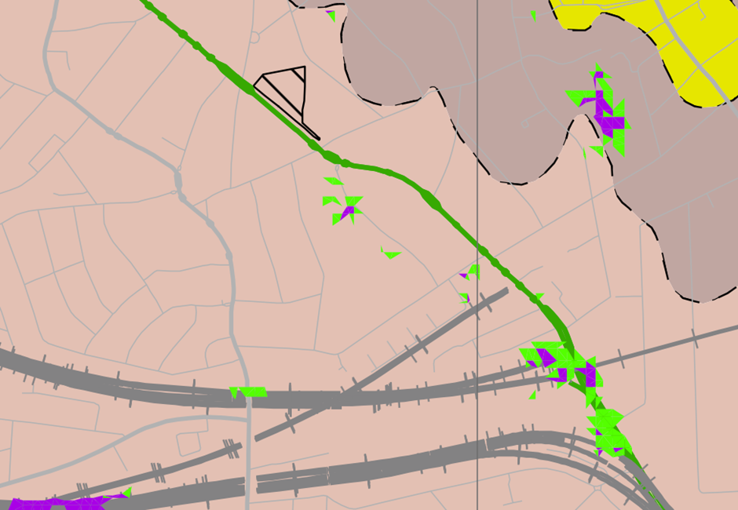
- Slope Angle and Worked Ground Map (LB Camden GHHS figure 16) e.g

Slopes in green, 7-10 degrees; Slopes in purple, <10 degrees

- Geological Map Extract, BGS (Geology of Britain Viewer) e.g.
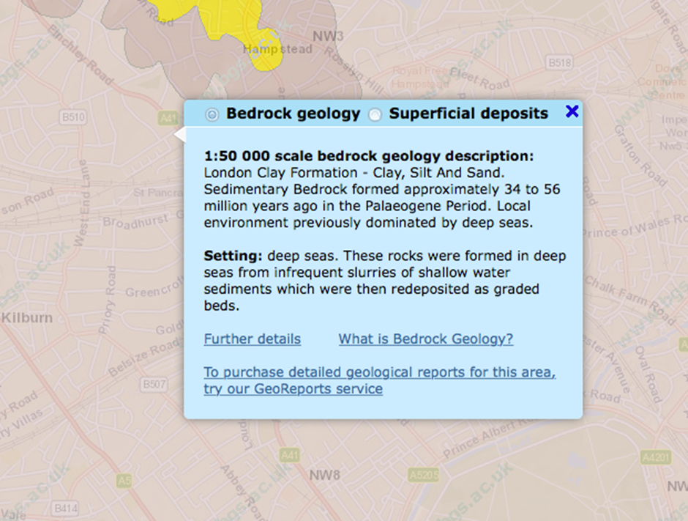

- Flooded Streets Map (LB Camden GHHS Figure 15) e.g

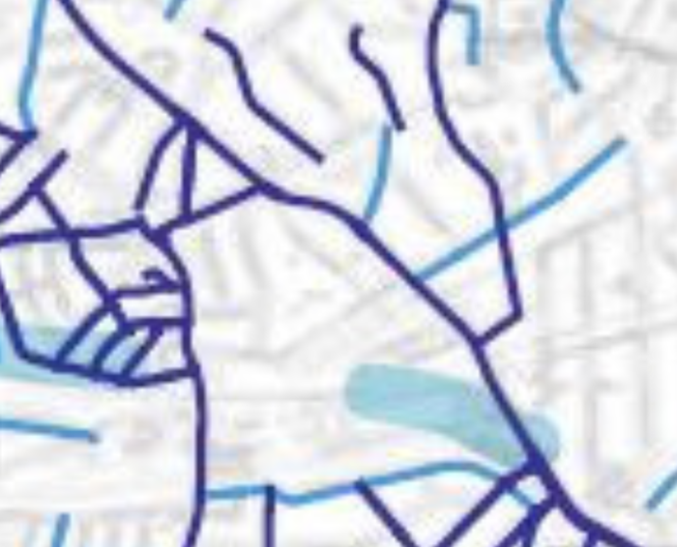
The highlighted streets are known to have flooded in 1975 and 2002. The site (within the red circle) has been affected by historic flooding.

- Flood Risk Map, Environment Agency (Surface Water Flood Risk) e.g.

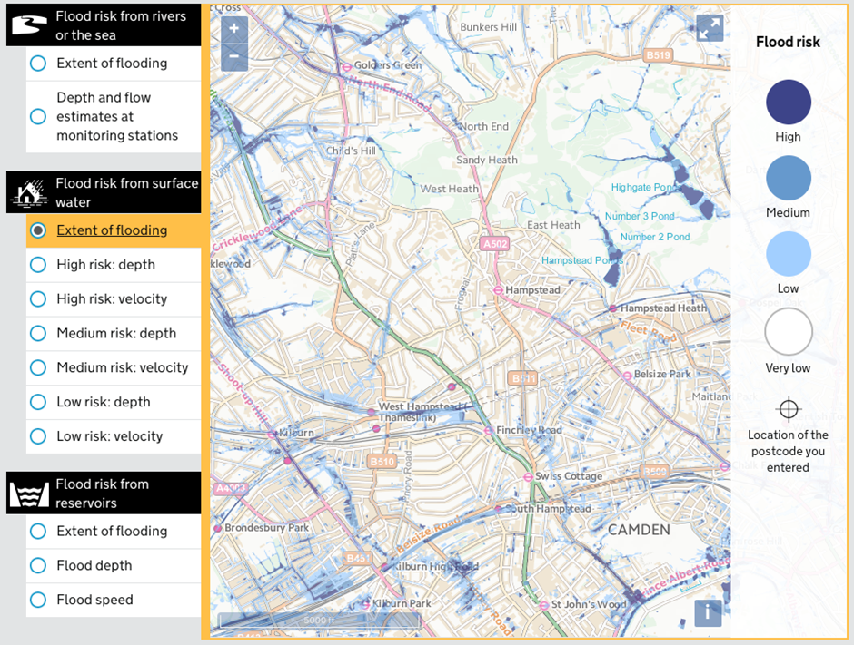
- Groundwater Source Protection Zone (LB Camden GHHS Figure 8) e.g
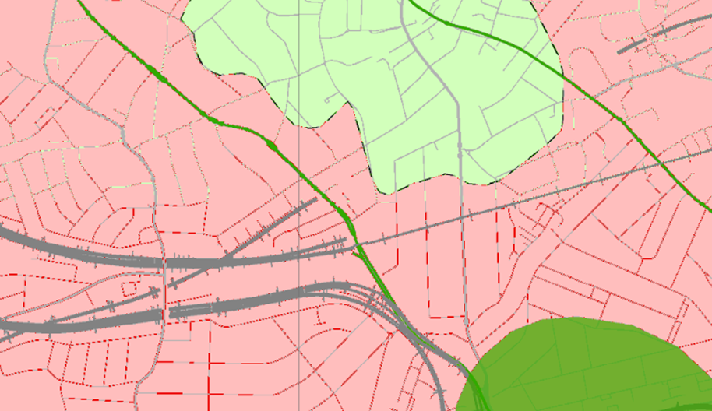

- Historical Water Courses (LB Camden GHHS Figure 11) e.g

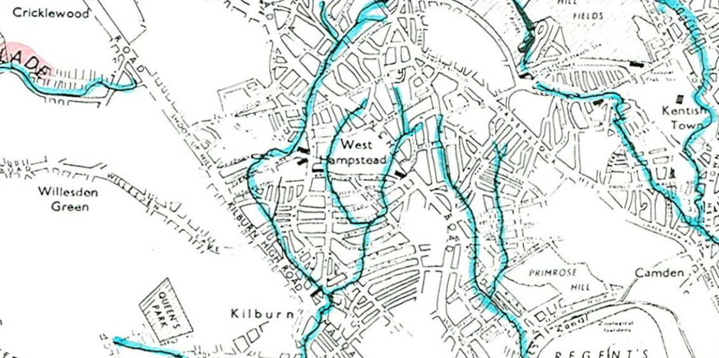

- Transport for London Property Asset Register e.g

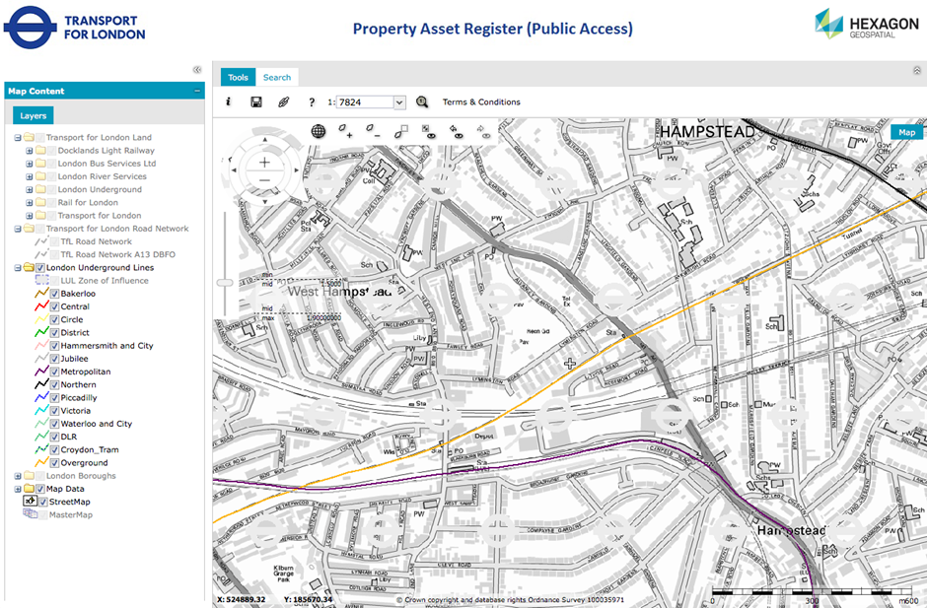

Appendix 2: Site Investigation Data

Appendix 3: Existing and Proposed Development Drawings
Appendix 4: Ground Movement and Damage Impact Assessment
Appendix 5: Structural Engineer’s Statement and Calculations
Appendix 6: Arboricultural Report/Other Reports (as required)
Appendix 7: Utility and Infrastructure Consultations

https://www.camden.gov.uk/localplan

