Working with you

When working with you, we will:

- Involve you and ask for your suggestions about how we can improve our service.

- Make sure you know what services we are offering you.

- Make our service as accessible as possible.

- Treat you with respect.

- Challenge discrimination, including behaviour or language that is sexist, racist or homophobic.

- Withdraw our services if you are aggressive or threatening. This could mean we can’t help you if you are under the influence of alcohol or non-prescribed drugs.

- We aim to get things right. If there is a problem, call our duty manager on 020 7974 5366. If you are still unhappy, you will be given details of our formal complaints procedure.

Hours of service

Office hours are 9am–5pm. However, the service is available between 8am and 6pm by prior arrangement. This means that if you are working we can arrange to see you at a time that suits you.

For further information, please call FSS duty desk on 0207 974 5366

www.camden.gov.uk
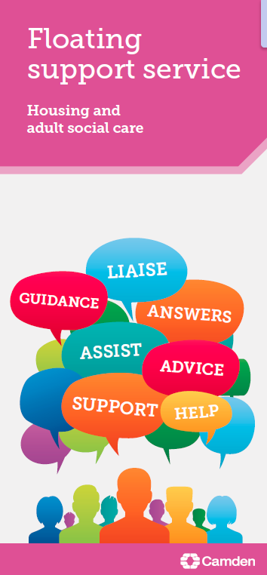
About us
We support vulnerable adults and families who need extra help to sustain a tenancy and achieve independence.

We support

- People around resettlement
- Families to access required services
- People aged 18 and over
- Offenders and people at risk of offending
- People fleeing domestic violence
- People with health issues
- People with mental health needs
- People with a learning disability
- Young people leaving care
- People with a physical disability
- People with substance misuse issues
- People with sensory needs

We can help you

- Get rent arrears under control
- Claim welfare benefits you are entitled to
- Learn about managing your money
- Work towards and achieve a healthy lifestyle
- Register with a doctor and dentist and access other health services
- Access specialist services

Am I eligible?

You can receive housing-related support if your tenancy is at risk and you are

- Already living in your own independent accommodation in Housing association, privately rented housing or as a homeowner, and are at risk of losing your home
- Moving into your own independent accommodation via the adult or young person’s pathway
- Moving into settled privately rented accommodation via Housing Options, and you have an identified support need
- Placed in temporary accommodation by Camden, either within the borough or in another London borough

Who can refer?

Referrals can come from a range of routes, including:

- You can refer yourself
- Camden Council’s Housing Needs Group
- Adult Social Care
- Children, Schools and Families
- Registered Social Landlords
- Primary Care Trusts/GPs
- Community Mental Health Team
- Substance Misuse services
How to apply

Referring agencies should complete a referral/risk assessment form and email it to FSSReferrals@camden.gov.uk.

You can refer yourself by calling 020 7974 5366 or by using the email address above. We will carry out a referral with you over the phone or we can post or email a form for you to complete.

Once we receive a referral, we will aim to contact you within five working days and see you within 10.

Floating Support Service
By appointment only:

5 Pancras Square
London
Camden
N1C 4AG

Tel: 020 7974 5366
www.camden.gov.uk

